Philippine Bus Number Identification

Jedidiah Caychingco
De La Salle University
2401 Taft Ave, Malate, Manila,
1004 Metro Manila, Philippines
jedidiah_caychingco@dlsu.edu.ph

Abstract—In this paper the author discusses a way to isolate the area containing the bus number using edge detection, morphological operations, and image segmentation. The training set consists of 15 images of Jag Liner busses whose bus number is titled by at most 30 degrees. The images are of different sizes: the smallest being 500x375 px. while the largest is at 1024x768 px. Furthermore, the images are taken with ample illumination. The program produced an accuracy of 20%
Keywords— bus number identification; Sobel edge detection; morphological operations; image segmentation; variable-sized input.

Introduction
Bus numbers are an effective medium to identify buses since it is unique. Bus number identification has several applications such as in law enforcement, bus tracking, and others. However, it is also a challenging task due to the variations in illumination, angles, and others. The task if further made difficult due to there being no standard for bus numbers. In order to standardise the data, the sample used is only from Jag Liner buses.
The following parts of the paper are organized as such: section 2 presents the review of related literature, section 3 describes the algorithm used, section 4 shows the results, and section 5 is where the author details the conclusions and his recommendations in order to improve the accuracy of the program.

Review of Related Literature
Since the majority of the related literature concerns itself with finding the location of a licence plate (LP) instead of a bus number, their approaches were modified and adapted in order to fit the task at hand.
In order to filter out unneeded information from the input image, [3] made used of the vertical Sobel edge operator in order to get the edges of the image and a threshold to remove the small edges. His rationale is that long edges contain relevant information about the image and are separate from the image’s background. He then removes the area outside of the long edges since that corresponds to the background.
[4] made use of vertical edge detection combined with morphological operations in order to get the location of the LP.

[2] used morphological operations and support vector machines (SVM) in order to locate the LP and identify its contents. His approach combines rule-based methods in order to get the LPs location and a machine learning classifier in order to identify the characters in the LP.

Algorithm Description
The program made use of a variety of methods to pre-process its input. In order, they are namely: Greyscale conversion, getting the area of interest, image pre-processing, and bus number candidate selection.

Greyscale conversion
A coloured image is in the RGB (Red, Green, Blue) format wherein each pixel is comprised of red, green, and blue components at different intensities. In order to convert the image into its greyscale equivalent, the RGB value in each pixel must be multiplied by a certain value specified by (1). [1] noted that processing images in greyscale will result in faster processing and offers a uniform range of values. “Fig. 1-2”
0.2989*R + 0.587*G + 0.114*B 

Getting the area of interest
After converting the image into greyscale, its irrelevant parts are removed. Irrelevant parts are defined to be the background of the bus as well as the upper half of the bus. [3] The upper half of the bus is removed since the bus number is located below it.
In order to separate the bus from its background, the vertical Sobel edge operator in Fig. 1. is used. Short edges, those whose height is less than 1/8 that of the image, are removed. The rationale in this setup is that tall edges would correspond to the bus body while areas outside it would correspond to the background. This operation causes the image to be binarised i.e. all the elements in the image would be composed of 1s and 0s. A convex hull is created from the borders of the tall edges. This convex hull encompasses the entire bus and is used to separate the it from its background. Afterwards, the upper half of the current bus is then removed to further isolate the bus number. “Fig. 3.”

1 | 2 | 1
0 | 0 | 0
-1 | -2 | -1

- Vertical Sobel edge operator

Image preprocessing
The morphological operations opening and dilation is then applied to the image in order to increase the areas of its components. “Fig. 4.” [1] Areas in the image that are enclosed in borders are then filled in. “Fig 5.” The edges are then thinned and areas that cannot be filled in are removed. Ideally at this stage, the bus number will appear to be a blob. However, many other areas in the image will look like blobs as well.

Bus number candidate selection
In order to disambiguate the location of the bus number, we will remove candidates whose dimensions are not that of a bus number as was done by [2] “Fig. 7.” His rules for determining the eligibility of an area are as follows:
- A width to height ratio of [1.5, 2.5]
- A minimum width of 30
- A minimum height of 11
The current image containing the remaining candidate areas are then multiplied with the initial grey scale image in order to bring back content to the blobs. “Fig. 8.”
The abovementioned rules have significantly reduced the number of candidates since it removes areas such as the bus body design, bus name, wheels, etc. However, there are still incorrectly identified areas, specifically those that contain noise. In order to rectify this, we made use of an additional rule requiring the candidate area to have a specific number of segments. “Fig. 9-10.”
- Number of segments = [3, 9]
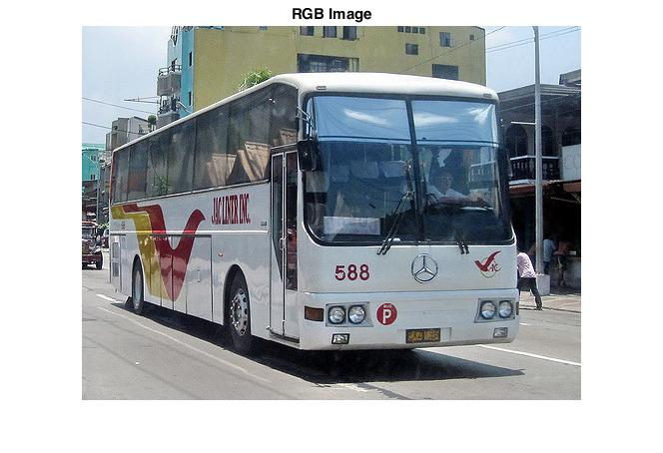Fig. 2. RGB image
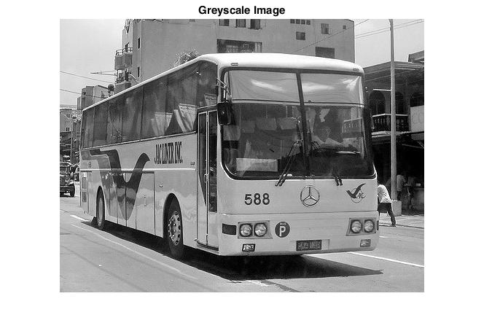Fig. 3. Grey scale image 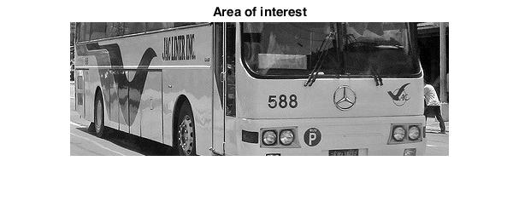 Fig. 4. Area of interest 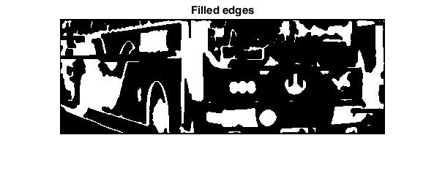Fig. 5. Filled edges 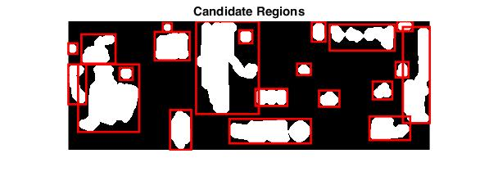Fig. 6. Candidate regions
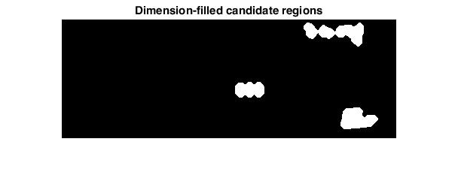Fig. 7. Dimension- filled candidate regions 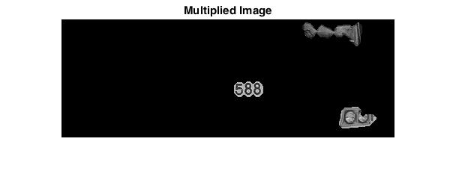Fig 8. Multiplied image 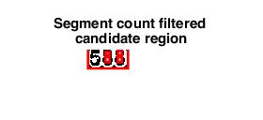
Fig. 9. Segment count filtered candidate region 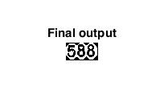
Fig. 10. Final output

Results
Among the 15 test images, only 3 were able to be successfully captured by the program. This results in an accuracy rating of 20%.

Conclusions and Recommendations
An interesting thing to note with the valid results is that one of them contains a bus that was taken from its side whereas the other images were taken mostly from their front. Aside from this, there are little similarities among the three valid results that would allow them to stand out from the rest. Therefore, it is likely that it is only by change in which the accuracy was obtained.
Among the invalid areas produced by the program are: the LP of the bus, its destination placard, and its bumper among other areas. The low accuracy can be attributed to problems during the pre-processing of the image wherein even the bus number is removed. A way to improve upon this is to take into account additional variables in removing invalid candidate areas as well as to conduct more experiments regarding changing the weights of the program.
A bigger sample size would also benefit the future researchers in improving the application. The small sample size used in this paper is brought upon the difficulties in getting the images. This resulted in the researcher relying on images found online for the data set.
A problem with tracking buses using their bus number is that there is no standard to them; some bus numbers are located below the wind shield whereas some are at the upper portion of the windshield. Therefore, for this approach to be more effective, it is necessary to create a means of identifying bus numbers with a variety of formats.

References

- R. Chen and Y. Luo, "An Improved License Plate Location Method Based On Edge Detection", Physics Procedia, vol. 24, pp. 1350-1356, 2012.
- A. Rabee and I. Barhumi, "License Plate Detection and Recognition in Complex Scenes Using Mathematical Morphology and Support Vector Machine".
- A. Rashid, "A Fast Algorithm for License Plate Detection", Internation Conference on Signal Processing, Image Processing, and Pattern Recognition [ICSIPR], 2013.
- Y. Sun and W. Zhou, "License Plate Extraction Based on Vertical Edge Detection and Mathematical Morphology".

